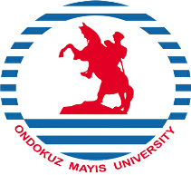
REPUBLIC OF TÜRKİYE
ONDOKUZ MAYIS UNIVERSITY
INTERNATIONAL RELATIONS OFFICE

LETTER OF INVITATION
ERASMUS+ KA1: LEARNING MOBILITY OF INDIVIDUALS
STAFF MOBILITY FOR TRAINING
We hereby cordially invite

……………………………………………………………………..

from Ondokuz Mayıs University

in Samsun / Türkiye

to visit and do training at

………………………………………………………………………

On

……………………………………………………………………..

To be completed by the host institution:
Name:
Position:
Signature:
Seal:

_________________________________________________________________________________________________________________________________________
Tel: +90-362-3121919 (Ext. 1613) erasmus@omu.edu.tr Fax: +90-362- 4576091 55200 Atakum - SAMSUN – TÜRKİYE

