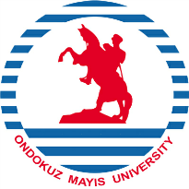
CONFIRMATION OF ARRIVAL
ERASMUS+
KA1 LEARNING MOBILITY OF INDIVIDUALS
STUDENT STUDY MOBILITY
ACADEMIC YEAR 2025-2026

Sending Institution: ONDOKUZ MAYIS UNIVERSITY TR SAMSUN01

Receiving Institution:

Student Name:

Date of Arrival:

Approved by:

Signature:

Title / position of signatory:

Stamp of institution:

Tel: +90 (362) 3121919-1613 Fax: +90 (362) 4576091 mehmet.tutuncu@omu.edu.tr / erasmus@omu.edu.tr 55200 Atakum - SAMSUN - TÜRKİYE

