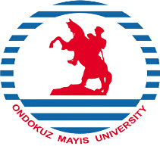
REPUBLIC OF TURKEY
ONDOKUZ MAYIS UNIVERSITY
INTERNATIONAL RELATIONS OFFICE

LETTER OF ACCEPTANCE
ERASMUS+ KA1: LEARNING MOBILITY OF INDIVIDUALS
STUDENT MOBILITY FOR TRAINING
We hereby accept

……………………………………………………………………..

from Ondokuz Mayıs University

in Samsun / Turkey

to do training at

………………………………………………………………………

Between the following dates

……………………………………………………………………..

To be completed by the host institution/enterprise:
Name of Host Institution/Enterprise:
Name of Responsible Person:
Title/Position of Signatory:
Signature:
Stamp of Institution/Enterprise:
Date of Signature:

_________________________________________________________________________________________________________________________________________
Tel: +90-362-3121919 (Ext. 1613) erasmus@omu.edu.tr Fax: +90-362- 4576091 55200 Atakum - SAMSUN - TURKEY

