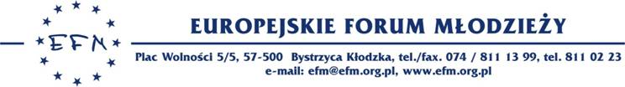

URGENT !!!
Invitation for EVS 4.6
Dear Partners and friends,
Europejskie Forum Młodzieży is glad to inform you that we have an approved EVS projects. We would like to invite you to take part in our action between 1st of February and 28th of March . In our project we can host volunteers from Latvia, Lithuania, Romania and Turkey for 8 weeks. We are looking for:
• 4 Romanian
• 4 Turkish
• 4 Lithuanian
• 4 Latvian
The best thing is it doesn’t matter you had EVS before because it is a partnership building project ☺
Age limit is 18-30
The EVS is in frame of project 4.6 - we can finance only 50% of the travel costs. Food and accommodation is provided.
About our organization:
Europejskie Forum Młodzieży (EFM) has been involved in European Voluntary Service since 2001. Ever since that time we have been cooperating with the YOUTH and Youth in Action Programme, sending people on short- and long-term projects throughout Europe. Since 2002 we have hosted and coordinated long-term projects, have been working with three schools in Kłodzko. One year later we started coordinating short-term projects, for which we work with the local municipality as well as with the Social Help Centre. We furthermore act as a hosting organisation ourselves. Our experience concerning EVS is given consequently.
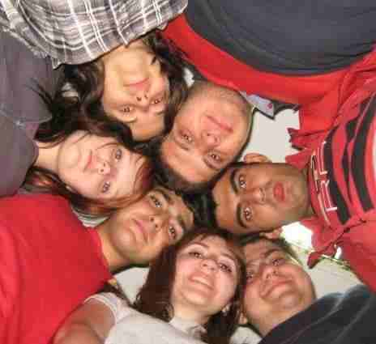
Project environment:
Bystrzyca Kłodzka is a small city located near Kłodzko Valley. The city has a population of around 15,000 inhabitants, all of Polish nationality. There is small minority of gypsy people leaving in the city, a group that sometimes finds it difficult to integrate. The town has a significant touristic potential and its economy and future development is depending on the promotion of its attractions. Ziemia Kłodzka is a region in the south-western part of Poland, within Lower Silesia, located in the Sudety Mountains.
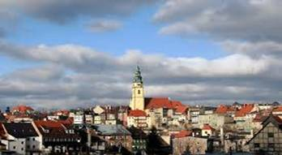

There is a lack of youth facilities, resulting in limited options for young people in how to spend their leisure time. This lack of creativity increases the need for more cultural and sports activities. There are many groups of young people in Bystrzyca Kłodzka and European Youth Clubs in the region, containing people with interests in theatre, music, dancing, and sports. However it is critical that they have adequate support and options to further development of their interests.

Proposed activities for EVS volunteers:
There is a possibility for the volunteer to take part in a number of activities within our organisation, for example:
1) Offering non formal education opportunities in form of language conversations or discussions on actual themes for local people. Education of this sort provides an attractive alternative for youngsters to the rather formal school education, an opportunity to test out their acquired language skills in authentic conversations and to realize the importance of foreign language knowledge. For adults, these conversations will provide an opportunity to reactivate and improve long forgotten language skills and regain confidence in using them. Also, for the volunteer this will be an opportunity to practice his/her training skills. When it comes to offering language conversation in his/her mother tongue, this activity helps the volunteer reflect on the structure of its own language and see how foreigners react to it.

2) Participating in the monthly 'EuroWeek' camps for young people from all over Poland and leading presentations at these camps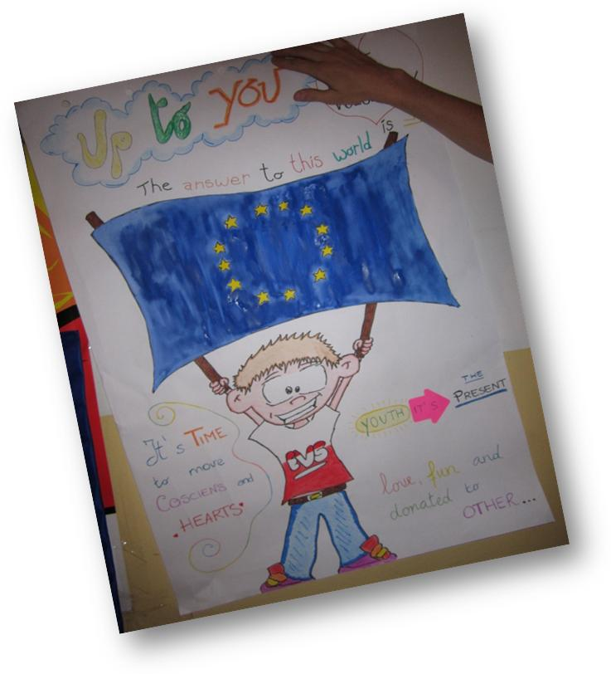 on various subjects (EU, stereotypes, the volunteer's country etc)
3) DPS (house for old people) is another activity we support. There the volunteers can play bingo and other group games with the people hosted, can accompany them for a walk or help the staff in providing them with food. Other activities in the house can be: working together in the garden, assisting in therapy sessions.

4) Helping in the office with the sending of Polish young people to be volunteers through EVS, or with the writing of emails, making of phone calls or translation of texts which use the volunteer's language skills. Usually the volunteers participate in meetings with candidates for EVS in order to share their experience, to give advices, to promote their project. Volunteers are not required to work in the office but if they enjoy helping with these tasks or they require this experience they are welcome to help us in this way.
5) Organizing events that aim at promoting cultural awareness and tolerance among the locals: European information campaigns, multicultural evenings, food festivals, etc.
The volunteers hosted in the project will chose to participate in different activities according to their skills and options. Therefore, the project is very flexible and the volunteer can combine three or four of the activities mentioned. This is also an opportunity for our volunteers to learn how to manage their own schedule according to the activities they chose.

If you are interested to take part in our project just fill the application from attachment and send to our e-mail address adam@efm.org.pl or sending@efm.org.pl till 20th of January.
Phone number : +48 608 320 983

Hope see you soon in Poland ☺

Magdalena Nicałek
Europejskie Forum Młodzieży
Europejskie Forum Młodzieży
Plac wolności 5/5
57-500 Bystrzyca Kłodzka
Poland
Tel/fax 0048 74 8111399

