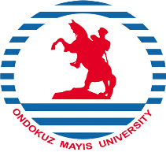
REPUBLIC OF TÜRKİYE

ONDOKUZ MAYIS UNIVERSITY

INTERNATIONAL RELATIONS OFFICE

LETTER OF CONFIRMATION
ERASMUS+ KA1: LEARNING MOBILITY OF INDIVIDUALS
TEACHING ASSIGNMENT
It is hereby certified that
…………………………………………………….

from Ondokuz Mayıs University, Türkiye visited
………………………………………………………..
on …………… – ……………..
within the EU Erasmus+ Program. While here, she/he gave 8 hours of lectures to the students and academic staff in
………………………………………………………
in the field of
………………………………………………………..
and has taken part in academic consultations, seminars, academic visits and other activities.

To be completed by the host institution:
Name:
Position:
Signature:
Seal:

_________________________________________________________________________________
Tel: +90-362-3121919 (Ext. 1613) erasmus@omu.edu.tr Fax: +90-362- 4576091 55200 Atakum - SAMSUN - TÜRKİYE

