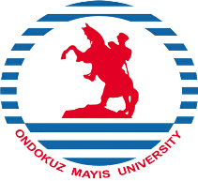
REPUBLIC OF TÜRKİYE

ONDOKUZ MAYIS UNIVERSITY

INTERNATIONAL RELATIONS OFFICE

LETTER OF CONFIRMATION
ERASMUS+ KA1: LEARNING MOBILITY OF INDIVIDUALS
STAFF MOBILITY FOR TRAINING
It is hereby certified that
…………………………………………………….

from Ondokuz Mayıs University, Türkiye visited
………………………………………………………..
on …………… – ……………..
within the EU Erasmus+ Program. While here, he/she had training at
………………………………………………………
in the field of
………………………………………………………..

To be completed by the host institution:
Name:
Position:
Signature:
Seal:

_________________________________________________________________________________
Tel: +90-362-3121919 (Ext. 1613) erasmus@omu.edu.tr Fax: +90-362- 4576091 55200 Atakum - SAMSUN - TÜRKİYE

